Exp 13

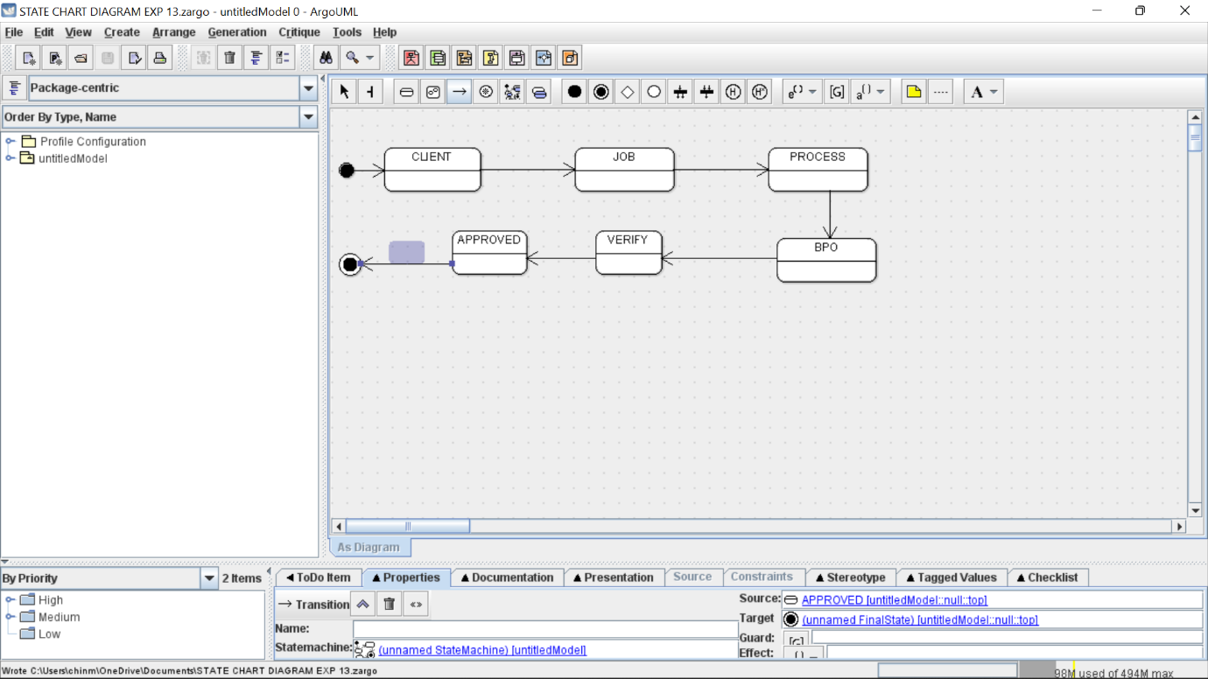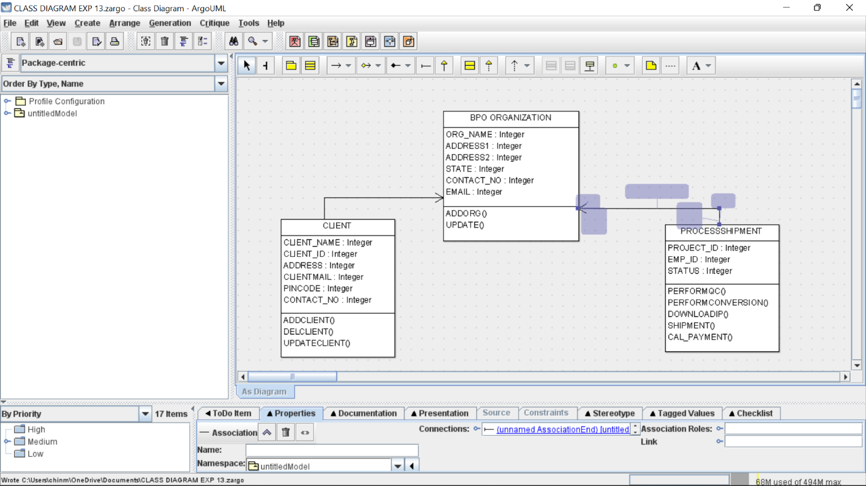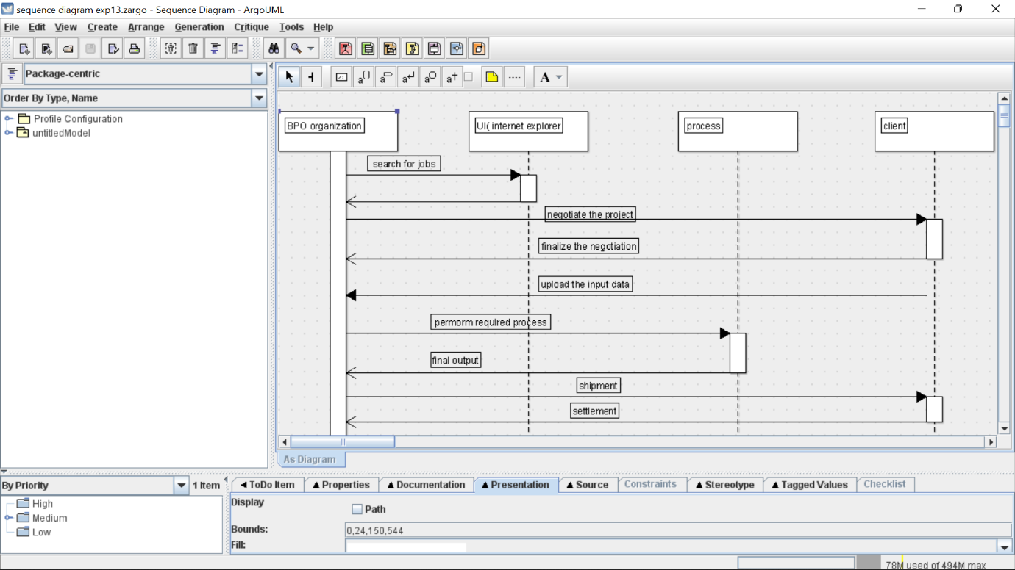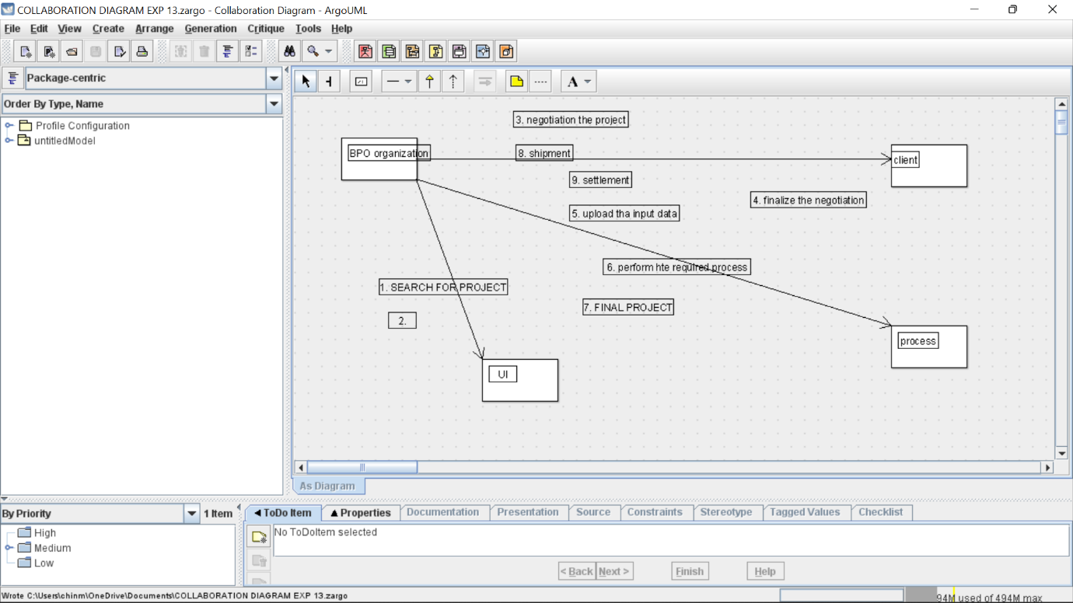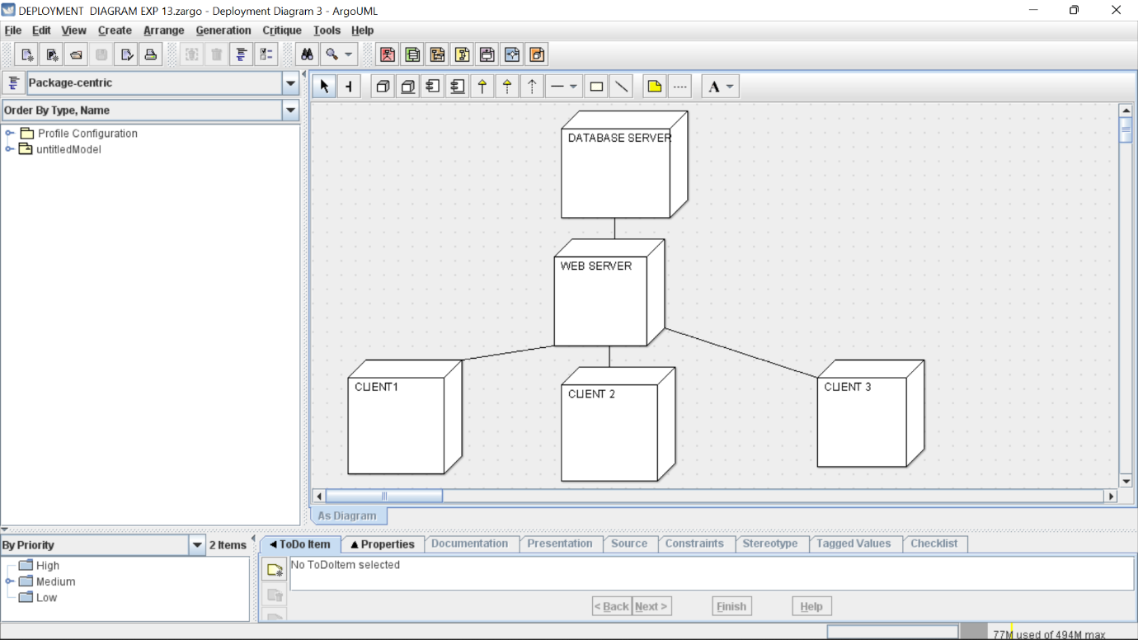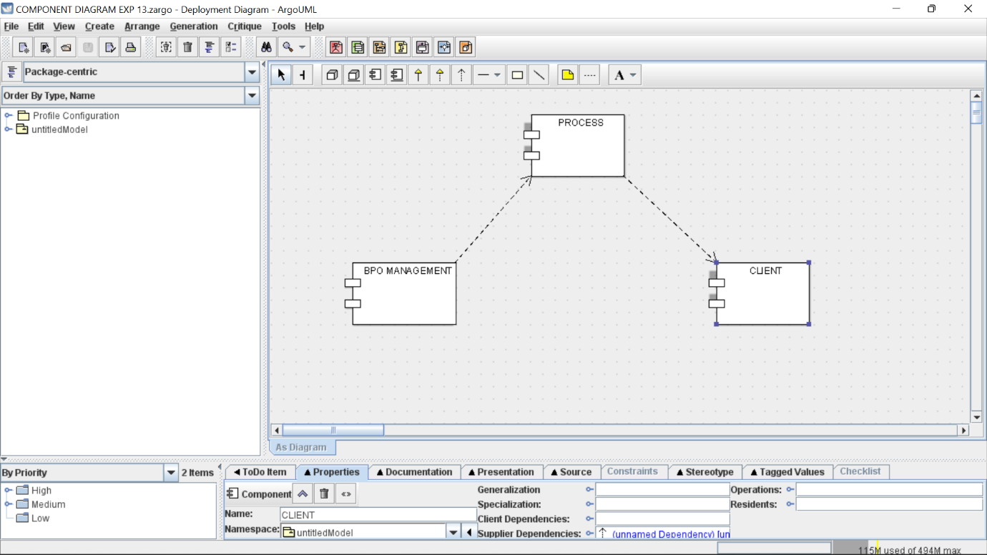

Skeleton code

public class BPO ORGANIZATION {

public Integer ORG_NAME;

public Integer ADDRESS1;

public Integer ADDRESS2;

public Integer STATE;

public Integer CONTACT_NO;

public Integer EMAIL;

public void ADDORG() {

}

public void UPDATE() {

}

}

import java.util.Vector;

public class CLIENT {

public Integer CLIENT_NAME;

public Integer CLIENT_ID;

public Integer ADDRESS;

public Integer CLIENTMAIL;

public Integer PINCODE;

public Integer CONTACT_NO;

public Vector myBPO ORGANIZATION;

public void ADDCLIENT() {

}

public void DELCLIENT() {

}

public void UPDATECLIENT() {

}

}

import java.util.Vector;

public class PROCESSSHIPMENT {

public Integer PROJECT_ID;

public Integer EMP_ID;

public Integer STATUS;

public Vector myBPO ORGANIZATION;

public void PERFORMQC() {

}

public void PERFORMCONVERSION() {

}

public void DOWNLOADIP() {

}

public void SHIPMENT() {

}

public void CAL_PAYMENT() {

}

}